Domain Group: Children w/Special Health Care Needs
Expert Guest(s): Dr. Steve Lauer, Dr. Pam Shaw, Julie Laverack, CHC-SEKS
Lead Staff: Kayzy Bigler Recorder: Connie Satzler

Instructions: Provide brief responses to the following questions related to the focus area/issue.
Discussion Questions | Comments
- What is the problem/focus issue? | Research indicates that children with a stable and continuous source of health care are more likely to receive appropriate preventive care, are less likely to be hospitalized for preventable conditions, and are more likely to be diagnosed early for chronic or disabling conditions. Only half of Kansas children have a medical home. Children with special health care needs are less likely to have a family-centered medical home than children without special health care needs.
- Who is the target audience for the message(s)? | Providers are primary/target audience for the messaging: How can they champion/lead and what opportunities are there for family-centered medical home support (increasing family satisfaction with communication w/dr.); family awareness (target: providers re: nontraditional approaches to improve; communication strategies, engagement, small changes in a practice setting to increase support, for example establishing a patient advisory board).
- What type of document/product related to outreach/messaging are you preparing (what is the purpose) and why? (action alert, infographic, bulletin, etc.) | Action Alert/Call to Action  (Use data, strategies, tips, and reminders to send the messages to impact behavior; intent is to mobilize and activate/create and drive action across sectors – we are all a part of the solution and can do something now.)
- What MCH performance measure does this aim to address/support? | NPM 11: Medical Home (% of children with and without special health care needs, 0-17 years, who have a medical home)  Numerator: Number of children with and without special health care needs, ages 0 through 17, who meet the criteria for having a medical home (personal doctor or nurse, usual source for care, and family-centered care; referrals or care coordination if needed) Denominator: Number of children, ages 0 through 17
- Outline the case for need:  - Data/negative trends  - Behaviors to target for change that are contributing to the issue  - System and/or policy issues and barriers contributing to the problem  - Other contributing factors | Data: The most current data indicates the care received by 50.6% of Kansas children under the age of 18 met medical home criteria. Children with special health care needs (46.1%) were less likely to have a medical home than children without special health care needs (51.8%). (Source: The 2016-2017 National Survey of Children’s Health, 2 years combined)  Disparities:  - Children aged 0–5 years (51.0%) and 6-11 years (52.9%) were more likely to have a medical home than children aged 12–17 years (48.1%).  - Hispanic children (35.2%) were less likely to have a medical home than non-Hispanic white children (54.4%).  - Children living in a household with English as the primary language were more likely to have a medical home than children living in a household with a primary language other than English (52.0% versus 37.4 %, respectively).  - Children living in a household with two parents (currently married) were more likely to have a medical home than those with two parents (not currently married), those with only a mother (currently married (living apart), formerly married or never married), and those with all other family structures (55.6% compared to 41.6%, 40.2%, and 34.6%, respectively).  - 40.0% of children living in households with incomes less than 200 % of poverty had a medical home compared to 62.9% of children living in households with incomes of 400 % or more of poverty. The difference was significant.  Behaviors to Target:  System and/or Policy Issues:  Barriers to Address:  Other Factors to Consider:
- What are the “asks” from the audience? What changes/actions can make a difference? Specifically, how should we move forward with this “issue” area that needs to be advanced?
(Carry to action alert worksheet.)
NOTE: Break strategies/actions for change down by target population and provider or setting type

- What key message(s) or resources (phone numbers, websites, etc.) need to be communicated or promoted?
(Carry to action alert worksheet.)
NOTE: Break message down by target population and provider or setting type, if appropriate.

- Sources/References
MCH State Action Plan Objectives:
- Increase family satisfaction with the communication among their child’s doctors and other health providers to 75% by 2020.
- Increase the proportion of families who receive care coordination supports through cross-system collaboration by 25% by 2020.
- Develop an outreach plan to engage partners, providers, and families in the utilization of a shared resource to empower, equip, and assist families to navigate systems for optimal health outcomes by 2020.

What, if any recommendations, does the group have for the MCH State Action Plan related to this issue? Consider and discuss the following:

Is the issue/need adequately addressed in the plan?  Circle one (yes or no) and explain. | Yes | No
Does the group recommend any strategies to advance the work or improve the outcomes/measures?  Circle one (yes or no) and explain. | Yes | No

Significance & Data:
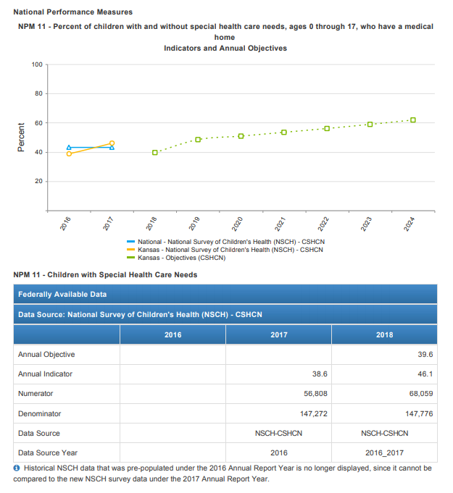
The American Academy of Pediatrics (AAP) specifies seven qualities essential to medical home care, which include accessible, family-centered, continuous, comprehensive, coordinated, compassionate and culturally effective. Providing comprehensive and coordinated care to children in a medical home is the standard of pediatric practice. The Maternal and Child Health Bureau uses the AAP definition of medical home. www.medicalhomeinfo.aap.org

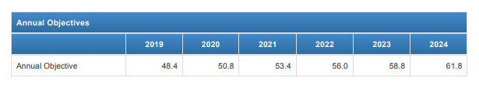

Resources:

- AAP Definition of Medical Home
A pediatric medical home is a family-centered partnership within a community-based system that provides uninterrupted care with appropriate payment to support and sustain optimal health outcomes. Medical homes address preventative, acute, and chronic care from birth through transition to adulthood. A medical home facilitates an integrated health system with an interdisciplinary team of patients and families, primary care physicians, specialists and subspecialists, hospitals and healthcare facilities, public health and the community.
- Kansas Family Engagement and Partnership Standards for Early Childhood (Key points as reference handout)
- American Academy of Pediatrics Family Engagement QI Implementation Guide
  - Fact Sheet as reference handout
- AMCHP Family Engagement & Leadership
  - Levels of Family Engagement in Title V as reference handout

